CURL:

curl, which stands for client URL, is a command line tool that developers use to transfer data to and from a server. At the most fundamental, cURL lets you talk to a server by specifying the location (in the form of a URL) and the data you want to send. including HTTP and HTTPS.

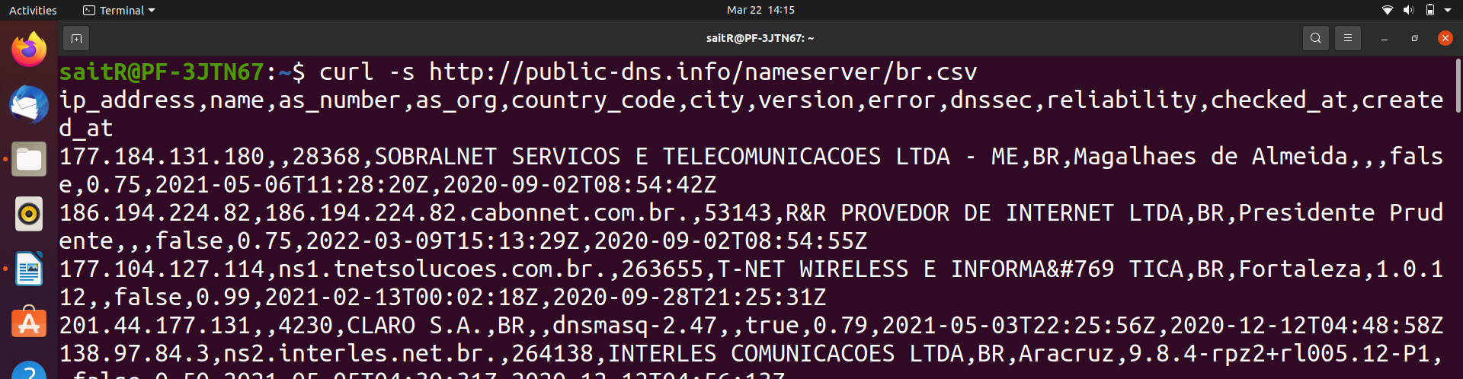

CUT:
the cut command in UNIX is a command for cutting out the sections from each line of files and writing the result to standard output. It can be used to cut parts of a line by byte position, character and field. Basically the cut command slices a line and extracts the text.
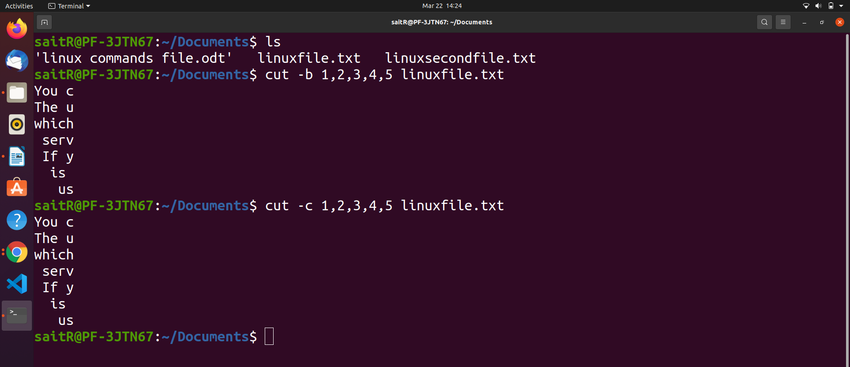

SHUF:

The shuf command in Linux writes a random permutation of the input lines to standard output.
When shuf command is used without any argument in the command line, it takes input from the user until CTRL- D is entered to terminate the set of inputs . And generate randomly the inputs you have given.
syntax:
shuf [OPTION] [FILE] //file shuf
shuf -i LO-HI [OPTION] ( shuf -n 2 file.txt )// display any random 2 lines from file.
shuf -e [OPTION]... [ARG] //list shuf
When -e option is used with shuf command, it works as a list shuf. The arguments of the command are taken as the input line for the shuf.
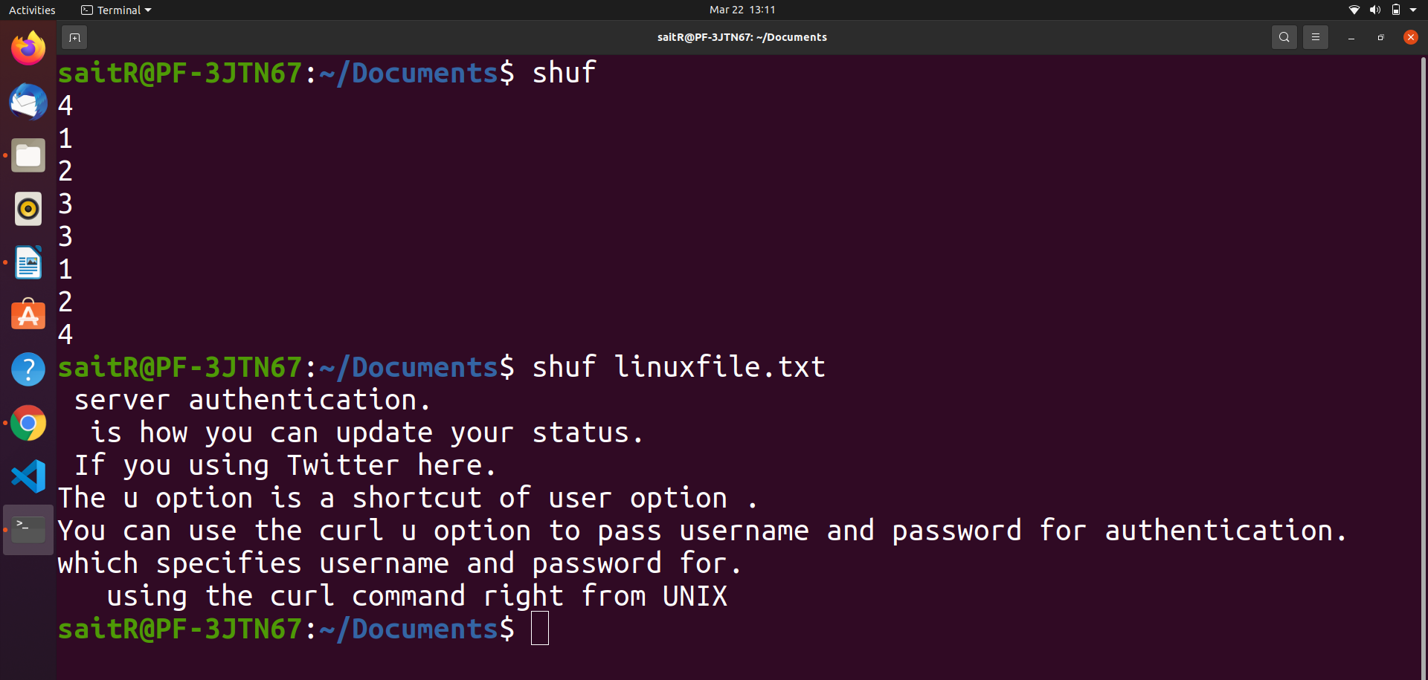
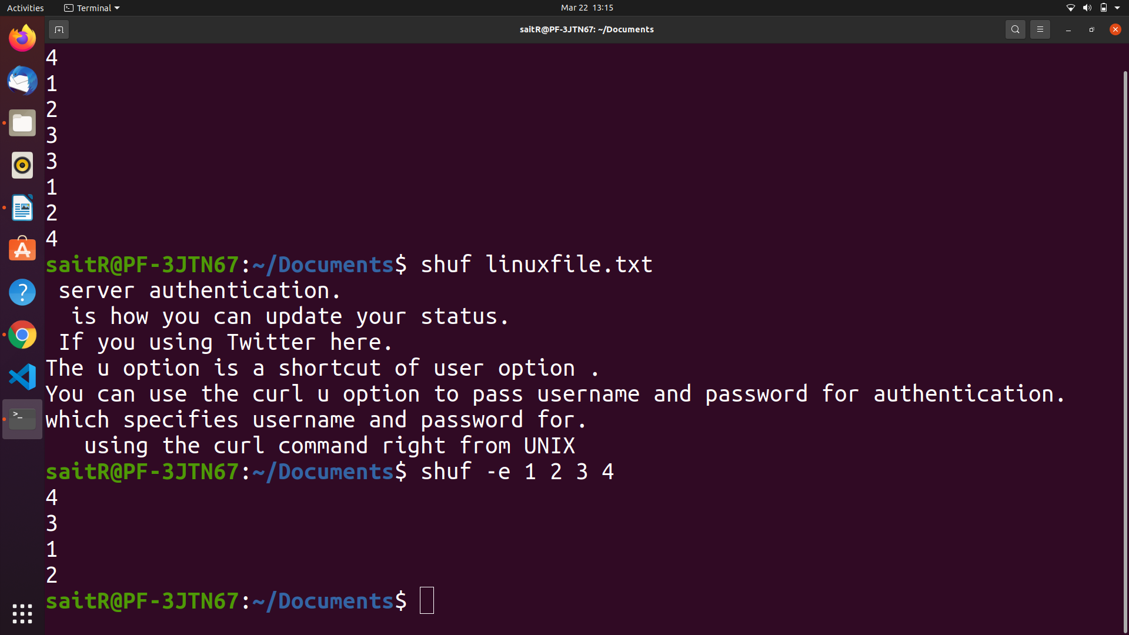

Grep :

grep is used to
The basic usage of grep command is to search for a specific string in the specified file .

Case insensitive search using grep -i
$ grep -i "the" demo_file

Syntax:
grep “string to find ” filename filename2

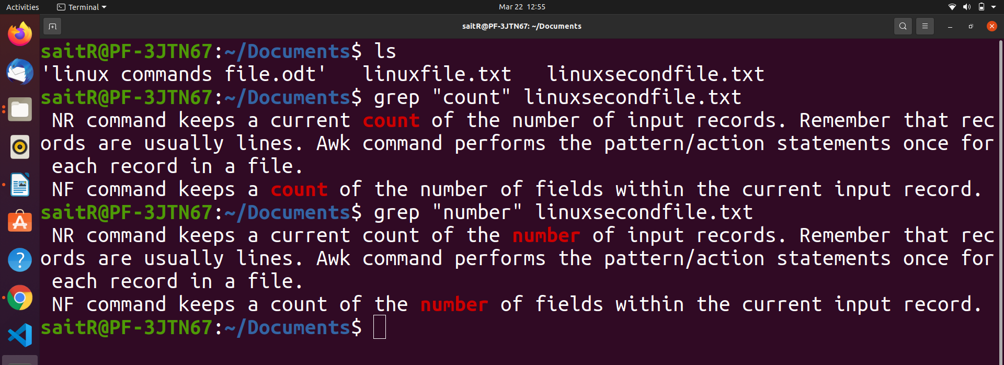

awk command with substring:

Awk is a utility that enables a programmer to write tiny but effective programs in the form of statements that define text patterns that are to be searched for in each line of a document and the action that is to be taken when a match is found within a line. Awk is mostly used for pattern scanning and processing. It searches one or more files to see if they contain lines that matches with the specified patterns and then perform the associated actions.

syntax:
awk options 'selection _criteria {action }' input-file > output-file

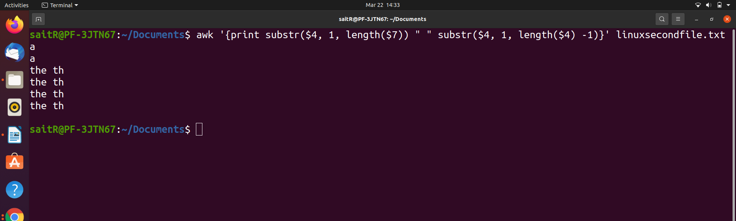

Tail:

The tail command, as the name implies, print the last N number of data of the given input. By default it prints the last 10 lines of the specified files. If more than one file name is provided then data from each file is precedes by its file name.

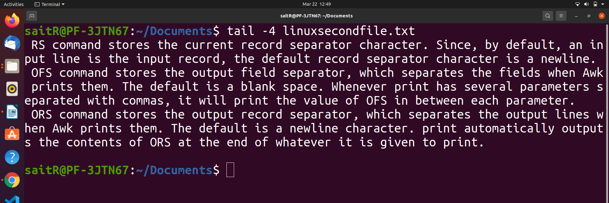

SORT:
SORT command is used to sort a file, arranging the records in a particular order. By default, the sort command sorts file assuming the contents are ASCII. Using options in the sort command can also be used to sort numerically. SORT command sorts the contents of a text file, line by line.

Syntax:
sort -n filename
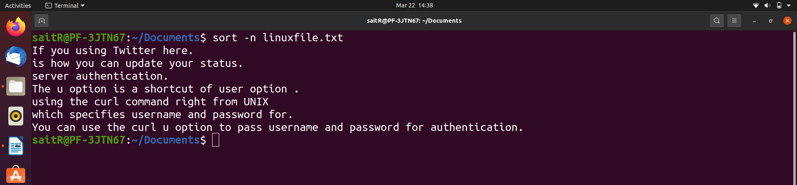

AWK:
It print the respective pattren the followed by attached to “ms” .

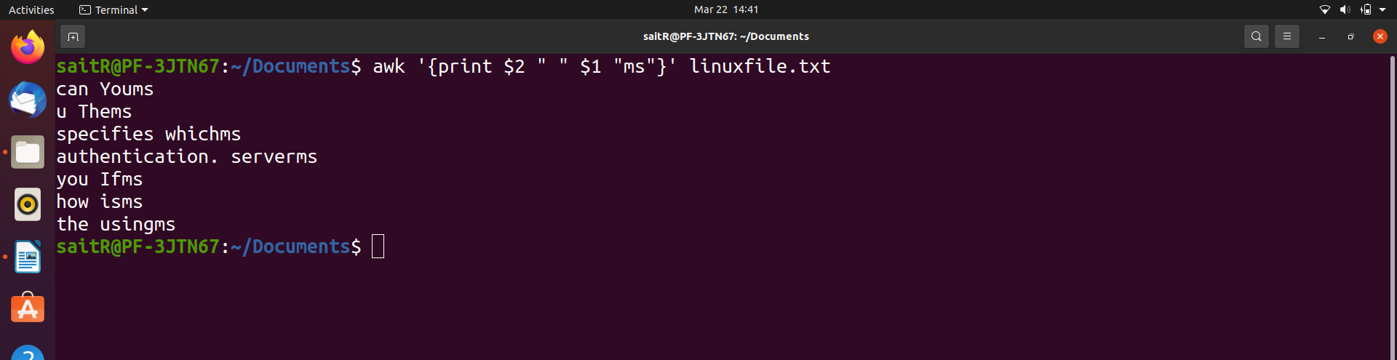

head:

The head command, as the name implies, print the top N number of data of the given input. By default, it prints the first 10 lines of the specified files. If more than one file name is provided then data from each file is preceded by its file name.
Linux head command is used to print first few lines of a file. By default, it prints first 10 lines of a file on terminal.

Syntax : head [OPTION]... [FILE]...
head -5 textfile.txt
head more.txt

